Welcome to CHARM Trader
The simple version · updated October 8, 2026
CHARM watches the stocks you choose and sells them following your exit plan: a target, a stop and a trailing safety net. You pick the account, the stocks and the settings. A rule being followed never guarantees a profit.
 | Meet CHARMie, your stock-watching assistant.  Buy a stock, put CHARMie in charge of the CHARM trail, and you do not have to sit at the screen. CHARMie keeps watching by your exit plan, gives a stock room to keep climbing, and watches for the trail that says it may be time to get out. It cannot guarantee a profit, and manual trading is always still available.
1. Get started
- Open https://173.208.162.111 and enter your saved full name.
- New user? Select SETUP, type the ACCESS CODE from your invitation, fill in your details and choose your passwords.
- Connect your broker (below). Alpaca is the easier one.
- Practice in PAPER (pretend money) first. Switching to LIVE (real money) needs your SETUP / LIVE PASSWORD.
- Choose which stocks CHARM may manage and set an exit plan (section 4).

Password | What it does
ACCESS PASSWORD | Signs you in every day.
SETUP / LIVE PASSWORD | Opens SETUP and KEY, and lets you switch to LIVE.
ACCESS CODE | One time only, to set up a new user. Not a password.
Your broker login is separate from all of these.

2. Connect your broker
ALPACA.
- Sign in at https://app.alpaca.markets and copy your Key ID and Secret Key. Paper and live are different pairs.
- In CHARM select SETUP or KEY and enter your SETUP / LIVE PASSWORD.
- Paste the paper pair into PAPER ALPACA KEYS (the live pair into LIVE ALPACA KEYS), then select SAVE ALL.
- Wait for the saved message, return to the portfolio, refresh, and check your holdings and balances.

SCHWAB.
It uses an approved developer app, not your normal login. At developer.schwab.com get your app approved. In SCHWAB SETUP enter the App Key as CLIENT ID, the App Secret as CLIENT SECRET and the CALLBACK URL exactly as registered, then SAVE SCHWAB KEYS. Select AUTHORIZE SCHWAB, sign in on Schwab’s page and approve the account. Copy the entire returned address, paste it into PASTE COMPLETE REDIRECTED ADDRESS and select CONNECT ACCOUNT. Schwab’s sign-in expires about every 7 days; if it stops working, just AUTHORIZE SCHWAB again with a fresh address.
Keep Secret Keys private. Never put them in screenshots or email. Paper keys cannot connect a live account.
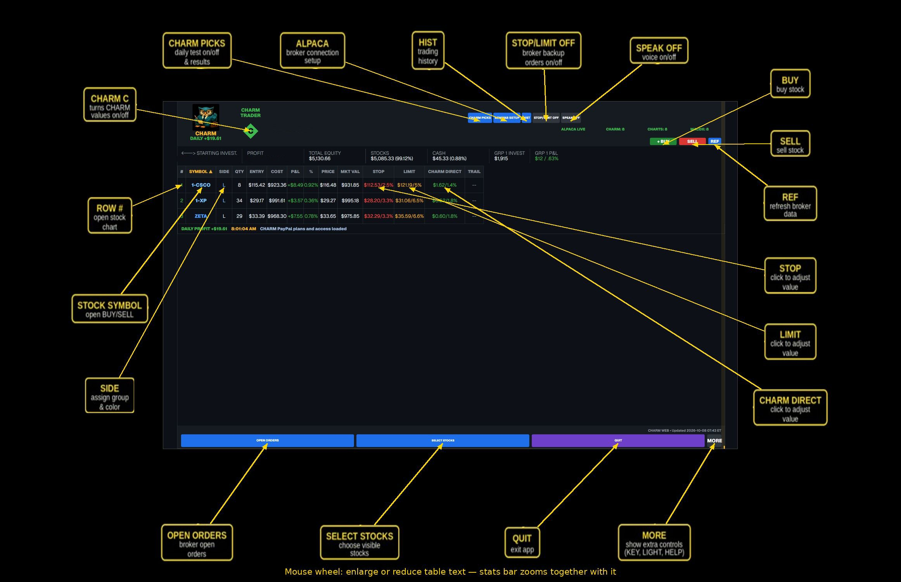

4. Set an exit plan
Select SELECT STOCKS, open a stock’s CHARM cell, set three numbers, then select APPLY.
- LIMIT (L): your target price for taking a profit. When price reaches it, CHARM holds instead of selling right away; if price falls back to the LIMIT before reaching LIMIT + CHARM, it sells at the LIMIT.
- STOP (S): a safety price that sells if the stock falls too far.
- CHARM (C): the trailing distance. When price reaches LIMIT + CHARM, the safety net starts following the highest price and never drops below the LIMIT.
Example: buy at $100, LIMIT $110, CHARM $2. A rise to $111 that falls back sells at $110. A climb to $112 starts the trail; if the stock reaches $115 and then dips, it sells at $113, and never below $110. Actual sale prices can differ from these numbers. Setting a number to zero turns that part off; REMOVE CHARM clears all three.
Keep the app open, awake and connected. CHARM and CHARMie can only act while the app is running. Your broker may also hold its own separate orders.
5. Buy or sell
- Select + BUY or SELL. Check the broker, account, PAPER or LIVE, and the symbol.
- Choose shares or dollars, then the order type: MARKET (now, price not guaranteed), LIMIT (your price or better, may not fill), STOP (becomes a market order at the stop), or TRAILING STOP.
- For LIVE, confirm once.
- Check OPEN ORDERS and your broker. A ticket is only a request; the broker must accept it and fill it.
WAIT FOR TICK UP (buys only, optional) holds the buy until the live price ticks up, then sends it. If no up-tick comes within the number of ticks you set, nothing is sent. If a sell seems stuck, check OPEN ORDERS first; an existing order can reserve your shares. HIST shows what actually filled, at the real prices.
Charts: click a row number to open a chart and use SELECT to change the style (CANDLE, LINE, MACD and more). A chart shows history, not a promise.
Need help?
Email info@charmtrader.com and say what happened and when. If you are unsure whether a trade went through, check your broker’s own app or website. Never send anyone your passwords or secret keys; support will never ask for them.

