MACD-Xrossing
Quick guide · updated October 29, 2026
What it is. MACDX looks for stocks whose MACD line has just crossed above its signal line (a “bullish crossover”), scores them, and lists the best matches. It only scans and reports. It never buys or sells, and no score is a promise that a trade will win.
Honest status: nothing here is proven yet. CROSS STRENGTH and the newer columns are still unproven. The forward tests below are how that gets settled. Fewer than 30 results is always preliminary.
PART 1 — MANUAL: YOU RUN THE SCAN
You choose the filters, start the scan, and read the results yourself.
1. Run a scan yourself
- Open a chart and select RUN MACD-X (the yellow button at the top of OPEN CHART). Typing MACDX in the symbol box and selecting LOAD also works.
- Use the default filters (or change them), then select START FILTERED SCAN.
- Click a result, then LOAD CHART. RETURN TO LIST shows all matches again.
Click a column heading to sort. “Evaluated” means stocks checked; “matches” means stocks that passed your filters. Neither means a proven winner.
2. Reading the main columns
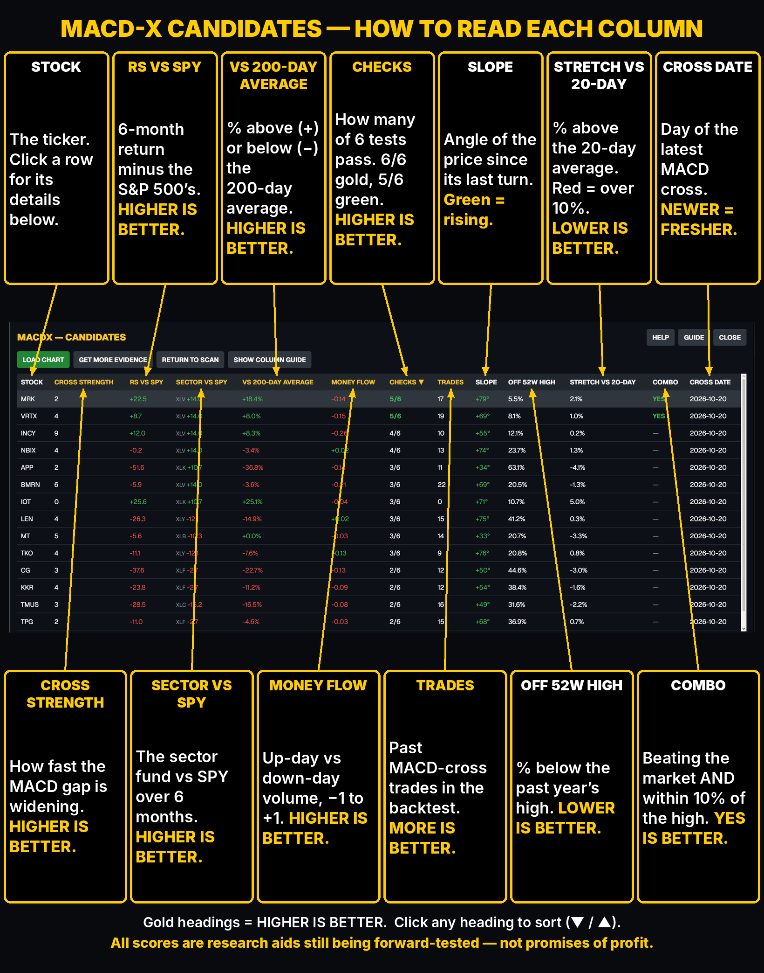
- COLUMN ORDER: every GOLD heading means HIGHER IS BETTER, and they sit on the left: CROSS STRENGTH, RS VS SPY, SECTOR VS SPY, VS 200-DAY AVERAGE, MONEY FLOW, CHECKS and TRADES. WHITE headings sit on the right: SLOPE, OFF 52W HIGH and STRETCH VS 20-DAY (lower is better), COMBO (YES is better) and CROSS DATE (newer is fresher). SLOPE shows just the angle; hover over it for the date of the turn and the total move.
- CROSS STRENGTH: how fast the MACD gap is widening versus the stock’s normal movement. Higher = faster. Not capped at 100.
- RS VS SPY: the stock’s 6-month return minus the S&P 500 ETF’s (SPY) return over the same dates, in percentage points. HIGHER IS BETTER: positive and green means the stock has beaten the market over 6 months; negative and red means it has lagged. Clicking the header puts the highest numbers first.
- OFF 52W HIGH: how far the last close is below the stock’s highest price of the past 52 weeks. LOWER IS BETTER: 0% means the stock is at its 52-week high, and 25% means it’s 25% below that high, so clicking the header puts the lowest numbers first.
- SECTOR VS SPY: the 6-month return of the stock’s sector fund (for example XLK for technology, XLV for health care) minus SPY’s, in percentage points. HIGHER IS BETTER: positive and green means the stock’s whole industry has beaten the market. Every stock in the same sector shows the same number. N/A means the sector wasn’t recognized (or the scan used typed-in symbols).
- VS 200-DAY AVERAGE: how far the latest price is above (+) or below (−) its average closing price over the last 200 trading days, in %. HIGHER IS BETTER: above 0 and green means the stock is in an uptrend; below 0 and red means a downtrend. MACD crosses tend to work better in uptrends. N/A means under 200 days of history.
- MONEY FLOW: Chaikin Money Flow over the last 20 trading days, from −1 to +1. Each day’s volume counts as buying when the stock closes near its high for the day and as selling when it closes near its low. HIGHER IS BETTER: above 0 and green means more volume on up-closing days than down-closing days (buyers in control); below 0 and red means sellers.
- STRETCH VS 20-DAY: how far the latest price is above its average closing price over the last 20 trading days, in %. LOWER IS BETTER: a stock that has just run far above its 20-day average often pulls back for a while. Over 10% shows red as overstretched. Clicking the header puts the smallest numbers first.
- CHECKS: how many of six tests the stock passes, shown as 0/6 to 6/6: COMBO YES, CROSS STRENGTH above 0, above its 200-day average, MONEY FLOW above 0, STRETCH under 5%, and SECTOR VS SPY above 0. HIGHER IS BETTER: 6/6 shows gold and 5/6 green. Each single column rewards one extreme (a stock can top MONEY FLOW while being badly overstretched); CHECKS puts the all-rounders first. Clicking a stock lists which tests it passed (✓) and missed (✗). Added 2026-10-21; new and unproven, tested the same way.
- COMBO: shows YES when the ideas line up together: RS VS SPY above 0 and no more than 10% below the 52-week high. YES IS BETTER: clicking the header puts the YES stocks first.
- NEW AND UNPROVEN: RS VS SPY, OFF 52W HIGH, SECTOR VS SPY and COMBO were added on 2026-10-19. Research has found that stocks beating the market and stocks near their 52-week high have tended to keep doing better for a while, but FORWARD TEST RESULTS has to show it here first: it saves each one’s top 10 (and every COMBO stock) every morning and compares them with all eligible stocks. Compare COMBO with RS VS SPY and OFF 52W HIGH alone to see whether the ideas work better together. VS 200-DAY AVERAGE, MONEY FLOW and STRETCH VS 20-DAY were added on 2026-10-20 and are tested the same way (STRETCH’s top 10 is its 10 least-stretched stocks). N/A means not enough price history yet.
PART 2 — AUTOMATIC: IT RUNS ON ITS OWN
Switch it on once; every market morning it scans, saves its picks and measures how they did.
3. Turn on the daily test

Turn the DAILY MACDX TEST switch ON (CHARM PICKS panel). Every market weekday at 9:20 AM Eastern it scans, saves its picks before the open, and later measures how they did. In the web version this runs on the server; in the desktop MACDX program keep its window open. Next morning, open DAILY TEST RESULTS. OFF stops new scans and keeps saved results.

4. What the Daily Test Results page shows
Select DAILY TEST RESULTS (CHARM PICKS panel) to open this report. It shows the LATEST SCAN: the CHARM CANDIDATES (the top 15 by CROSS STRENGTH) and which of them pass the live checks right now (section 5).
5. CHARM PICKS: the live checks
Checks start after 9:45 AM Eastern on market days. A stock must first be in the top 15 by CROSS STRENGTH, then pass all nine checks at once:
Check | Passes when
Rising price | up at least 0.05% over the last ~15 minutes
Above VWAP | at least 0.05% above the day’s volume-weighted average price
Strong volume | at least 1.5× normal for this time of day
Small spread | bid/ask gap 0.30% or less
Not extended | today’s move is no more than 1.5× the stock’s normal daily range
Reward vs risk | potential reward at least 2× potential risk
Market not against it | SPY not more than 1% below its 50-day average
Sector not against it | sector ETF not more than 1% below its 50-day average
Not reporting today | no earnings report today
CHARM PICKS = all passed (a current status, not an order). WATCHING – NOT READY = at least one check has not passed (open Details to see which). 3+ OF 9 CHECKS PASSED = stocks that passed at least the number of checks you choose; they are not picks. Empty lists are common; some days nothing qualifies.
6. The result buttons
The blue buttons in the CHARM PICKS panel open three reports:

Today’s scan from the daily test: the CHARM CANDIDATES and the live CHARM checks. See sections 4 and 5.

What happened after each stock was logged as a CHARM Pick: 1 hour, same-day close, 3rd and 5th close, and a simulated stop/trail exit.

Each morning’s top-10 by CROSS STRENGTH, RS VS SPY (higher is better), % BELOW 52-WEEK HIGH (lower is better) and STRONG SECTOR (higher is better), plus the COMBO GROUP, versus all eligible stocks, held 3 and 5 sessions, 0.1% costs each side. Rows with fewer than 10 mornings stay hidden until they have enough data. RECENT PICKS (press SHOW) lists the stocks behind each one with their results. “Vs baseline” is the number that matters: positive beat holding everything, negative did worse.
Before you trade
Treat every list as a shortlist. Open the chart and look at the LINE view (trend), the MACD view (is the cross still holding?) and the CANDLE view (steady moves, or long wicks and stalling?). Then decide for yourself. This guide is not financial advice.

